Category | Label | Value
Bug ID | ID number | 1
Bug ID | Name | TC: Verify owner admin is able to add new pet type
Bug ID | Reporter | KS
Bug ID | Submit Date | 03/15/2020
Bug Overview | Summary | Owner Admin not able to add new pet types
Bug Overview | URL | https://clinic.doveryai-no-proveryai.com/petclinic/pettypes
Bug Overview | Screenshot | 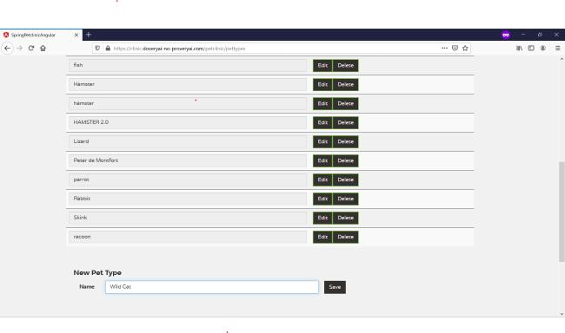
Environment | Platform | Windows 10 Pro
Environment | Operating System | 64-bit Operating System, x64-based processor
Environment | Browser | Firefox
Bug Details | Steps to reproduce | - Open URL https://clinic.doveryai-no-proveryai.com in firefox browser  - Click Pet Types  - Log in box will appear  - Enter username: owner_admin and password: admin and click OK.  - List of pet types will appear  - At the bottom of the page, click Add  - Enter Pet type in box and click Save
Bug Details | Expected Result | Pet types should be added to the list
Bug Details | Actual Result | Pet type will not add to the list
Bug Details | Description
Bug Tracking | Severity | Major
Bug Tracking | Assigned to | KS
Bug Tracking | Priority | High
Notes | Notes | Version 1.1

